COME JOIN THE SCARY FUN
SATURDAY OCT.25 6:30-11:30
1830 W. Glenrosa Ave.
Redemption Church Alhambra
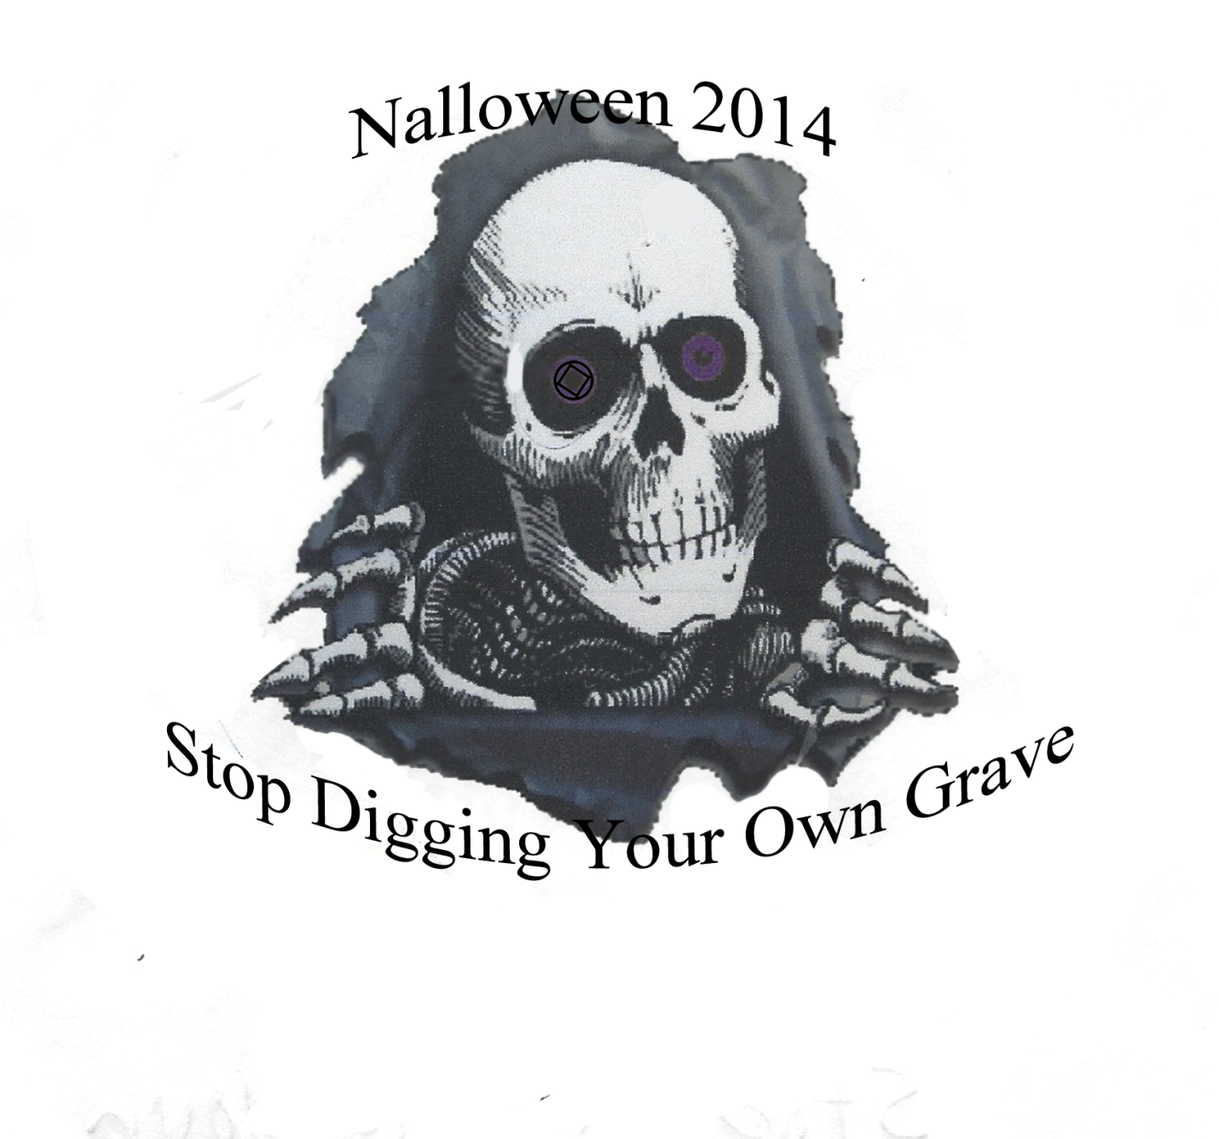
SPEAKER MEETING STARTS AT 7:00
DINNER SERVED AT 8:00
RAFFEL THROUGHOUT THE NIGHT
DANCE FOLLOWING DINNER
PRIZE FOR BEST COSTUME
FOR MORE INFO CALL DEB G -520-709-0490 –OR- FRANK W -602-434-6059

